

**Other information**



**Patient Information**

With thanks to Bristol, Musgrove Park, Isles of Scilly and Birmingham Hospitals.

References:

Chapman, T., Pincombe, J., Harris, M., Antenatal breast expression. A critcal review of the literature. Australia.

NHS Photo Library

Created by Cathy Gale – Infant Feeding Specialist Midwife – August 2012

Review date – August 2014 reviewed August 2014 Review date Aug 16

**Expressing Your**

**Milk Antenatally**

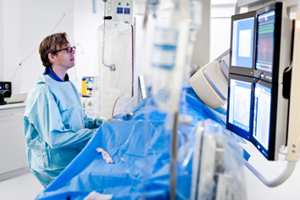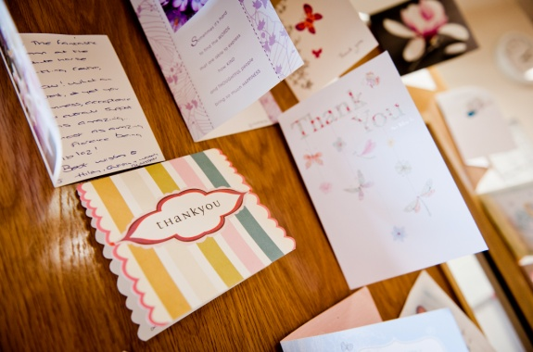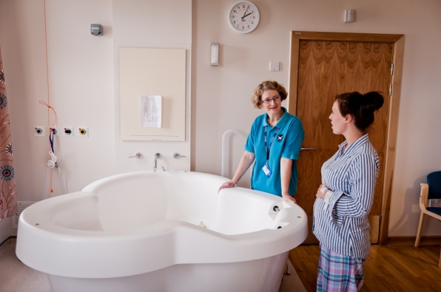



**Where to store my expressed colostrum~~s~~?**

**Breastfeeding & Diabetes**

* It is known that exclusive breastfeeding (which means your baby has your milk and nothing else to eat or drink) for around the first 6 months has many health benefits.
* Research shows that babies who are breastfed are less likely to develop childhood diabetes.
* It is thought that cow’s milk (the main ingredient in formula milk) can trigger diabetes in some babies; this is probably more likely for your baby if you or your partner have diabetes. Therefore it is very important that mothers who are diabetic avoid giving their baby formula milk if at all possible, until the baby is at least 6 months old.
* However, if you are a mother with diabetes, in the first few hours after birth, your baby may have a short time when their blood sugar is low and therefore your baby will need a little extra milk.
* To help prevent this you will be encouraged to give your baby frequent feeds. It is also very helpful if you have already expressed some of your breast milk (the first milk is called colostrums) so that it can also be given to your baby, if your baby does need extra milk, and so avoid the need to give your baby formula milk
* If you have diabetes and are insulin dependant you may find that your insulin requirements are lower when you are breastfeeding and that you need at eat more. If you have gestational diabetes, research has shown that you are less likely to go on to develop diabetes later in life if you breastfeed your baby.

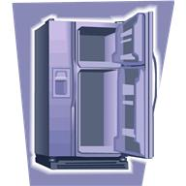

* You will need to collect the milk in clean container; the antenatal clinic staff can provide you with small syringes and stoppers which you can use to store the milk in. The syringe can then be ~~put into a small plastic bag and~~ labelled with your name, the date and time you expressed. We ask you to get yourself a plastic storage container measuring at least 18 cm long(7 inches approx) and a sheet of small labels to label your milk. Antenatal clinic staff can provide you with a “starter” pack of two syringes and you can collect a larger pack if you progress to larger amounts.
* You can store your milk in the fridge at a temperature of 2-4°c for between three and five days, or in the freezer for up to 6 months. If you do not know the temperature in your fridge at home then only store it for 48 hours.
* It will depend on how soon you will have your baby as to how best to store your milk. If you start expressing at 37 weeks it will probably be best to store that milk in the freezer, if you know you are going to be induced the next day then you can store that milk in the fridge.

**How to express your breast milk? (Cont’d)**

**Useful Information**

**I am not diabetic but this sounds useful, can I do this too?**

Yes, any mothers can hand express her breast milk from 37 weeks. It would be particularly useful if you know before the birth that our baby is at risk of having a low blood sugar in the first few hours after birth, this could be:

* Babies of mothers with severe pre-eclampsia
* Babies of mothers who are taking beta blockers to control their blood pressure (e.g. labetol)
* Babies are thought to be small compared to other babies at the same stage of pregnancy, or these who are expected to be less than 2.5kg when they are born.
* Babies who are twins or triplets

Any mother who wants to learn this useful life skill can express antenatally.

**Don’t forget to bring any breast milk you have expressed with you when you come into hospital to give birth, let your midwife know you have it with you and she will arrange for it to be stored in the fridge~~/freezer~~ on the ward.**

* If your breast milk is frozen, then the best way to transport it is in a cool bag with a blue cool box alongside it.
* If you are having your labour induced, you can usefully spend time learning hand expression if the labour is slow to start “Every drop counts”



1. Keeping the fingers and thumb in the same places on your skin, gently squeeze this area.
2. Maintaining this gentle but firm pressure, press your thumb and first finger together, easing the milk out of the milk collection pockets towards the nipple (see diagram D)

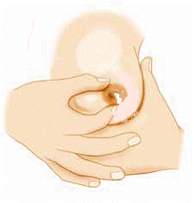

1. Continue this way with rhythmic squeezing movements. When the flow slows down, move your fingers around to a new position and repeat the movement. The milk collection pockets lie in a circle under the areola. If you think of them as a clock face you need to move your thumb and fingers so that the numbers have been emptied.
2. Repeat this expression on the second breast, and then go back to the first side again. When no more milk flows, express the second side again.
3. At first only a few drops will appear but keep going as it will help to build up your milk supply.



* As often as you want

**How much breast milk will I get?**

* This will vary from mother to mother from a few drops to a teaspoon. This first breast milk is very concentrated in nutrients and helps your baby to fight infections. This small amount is perfect for your new baby.

**Will my colostrum “run out”?**

You will continue to make colostrum until your baby is a few days old.The hormone changes in the first few days means the milk becomes less concentrated and has more volume by Day 4 If you express antenatally it doesn’t mean there will be no colostrum after birth.

**Why do this?**

* At GWH we want to support full breastfeeding wherever possible, so your own milk expressed antenatally and collected to be given by syringe will support this outcome.

**When can I Start?**

* It is thought to be extremely unlikely to cause a problem doing this before 36 weeks but we want to give you ‘research – based’ advice.
* There have not yet been any large or exact enough studies to prove that antenatal breast expression does or does not cause any increased uterus activity.
* For this reason we advise it after 36-37 weeks until further results are known. If you do start this technique any earlier, stop if you feel any increased uterus pain/activity.

NOTE: You may find that when you express you feel your womb going hard and relaxing – this is called ‘Braxton Hicks’ contractions. Don’t worry about these, unless they begin to feel like period type cramps or mild labour contractions. This is rare, but if it happens, you should stop expressing and rest. If they don’t stop and you think you might be in early labour, you should telephone the delivery suite as you have been advised to do by your midwife. 01793 604575

You can do this from 36 -37 weeks and the antenatal clinic staff will give you small syringes to store your breast milk in. The best way to do this in the antenatal period and the first few days after you have had your baby is by hand expressing.

Hand expression of breast milk is a very useful skill to have. You always have your hands with you and they do not need to be sterilised first!

Hand expressing is a more effective method of removing your colostrum~~s~~ (the first milk)

It is important to remember that there is no milk in the nipple. Milk will flow through the nipple, but there is no milk stored in it. Your breast milk collects in little pockets under the brown part of your breast; the areola and it is these that must be squeezed gently.

**How to hand express**

1. Put your thumb and fingers opposite each other, about 2 ½ - 3 ½ cm behind the base of your nipple (see diagram C). The exact position is different for each person so you may need to experiment to find the right place, sometimes you will feel a change of texture when you have found the right place.

(Diagram C)

**How to express your breast milk?**

**How Often Can I Express?**