Minor cuts and blisters
- Cover cuts or blisters with a sterile dressing
- Contact your GP or podiatry team.
- Apply an antiseptic.

Hard Skin and corns
- Do not use over the counter corn treatments as this can cause damage to the skin and lead to ulcers.
- Do not try removing the corn or callus yourself.
- Do make an appointment with your podiatry team for it to be removed.
- Contact your podiatry team immediately if the hard skin looks black.

Avoid high and low temperatures
- Never sit with your feet in front of the fire, or radiator.
- Wear socks if your feet are cold.
- Remove all hot water bottles and heating pads from your bed before getting in.

History of ulcers?
If you have had an amputation or ulcer before you are at a high risk of developing more foot problems. If you take care of your feet and attend regular podiatry treatment, you will reduce this risk.

If you are worried contact your GP or Podiatrist

Local contact numbers

Extension: 4300
Fax: 4508
Reception: 4030
Email: diabetespodiatry.ref@gwh.nhs.uk

……………………………………………………..

……………………………………………………..

……………………………………………………..

……………………………………………………..

……………………………………………………..

High Risk
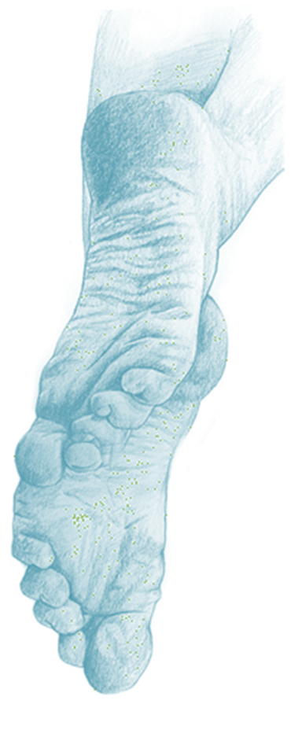

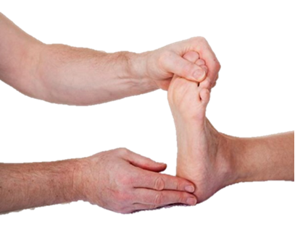

About diabetes
Diabetes is for life. It can be diagnosed at any age.
Nerves and blood vessels supplying your feet can be damaged. This can affect:
- The feeling in your feet (neuropathy)
- Circulation supplying your feet (ischaemia)
Changes to your feet can take a long time to show themselves and can go unnoticed. It is therefore very important that you check your feet daily, and attend your annual diabetic foot check.

You have a high risk that you will develop foot ulcers. Your podiatrist will tick which of the following risk factors you have.
- You have lost some feeling in your feet.
- The circulation in your feet is reduced.
- You have hard skin on your feet.
- The shape of your foot has changed.
- Your vision is impaired.
- You cannot look after your feet yourself.
- You smoke.
- You have had ulcers before.
- You have had an amputation.

You can reduce the risk of developing foot problems by having your feet checked annually by your practise nurse, diabetic nurse, GP or podiatrist, as well as controlling your diabetes, cholesterol, blood pressure, and to stop smoking.

If you smoke, we encourage you to stop. Smoking affects circulation which can lead to amputation.

Following the advice in this leaflet, will significantly reduce the risks of you developing a foot ulcer, which can increase your risk of amputation.

Keeping your feet healthy

Check your feet every day
Look for signs of blisters, breaks in the skin, signs of infection such as pain, pus, swelling and redness. Corns and callus. Use a mirror or ask a friend help you.

Wash your feet everyday
Use warm water and a little soap. Test the temperate of the water beforehand. This will also help you check for any changes to your feet or your skin. Dry your feet well, especially between the toes. If you find that they remain wet even after drying, apply a little surgical spirits. This will help dry them out.

Moisturise your feet everyday
People with diabetes suffer from dry skin; apply a little moisturiser everyday avoiding the areas in between your toes.

Toenails
Do not cut your toenails, instead file them.

Socks, stockings and tights
Change your socks, stockings or tights every day. They should not be too tight, or have bulky seams.

Avoid walking barefoot
You can injure yourself by stubbing your toes or standing on sharp objects causing damage.

Check your shoes
Check the inside and out sides of your shoes with your hand for anything that could have fallen inside, or be stuck on the outside such as a nail, pin, glass or dirt and debris.

Badly-fitting shoes
Check the inside of your shoes before purchasing them for any seams that may rub against your skin. Poorly fitting shoes that are either too tight or not supportive enough are a common cause of foot problems. Your podiatrist may suggest you have special shoes made for you on prescription. It is important to remember to judge your shoes on shape, not feeling.

Prescription shoes and orthotics
If you have prescription shoes or orthotics, you must follow the advice given to you by the Orthotist or podiatrist.

These should be the only shoes you wear.
Orthotics should be worn in all your shoes. Repairs on either the shoes or orthotics should only be carried out by the department that made them.

Written by Hannah Beute/reviewed by Diabetic foot team
Date: June 2017
Review date June 2018

