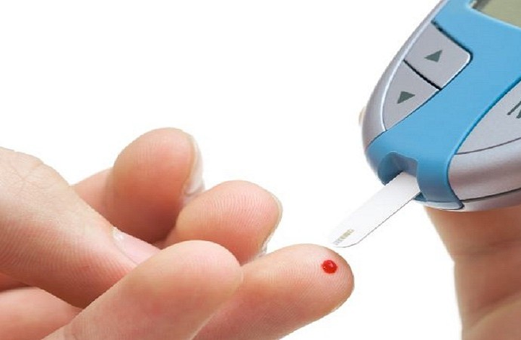

Overview

When you have diabetes, it is important to manage your blood glucose level both to help you feel your best and prevent long-term complications. Monitoring your blood glucose levels yourself with a blood glucose meter is an effective way to help you manage your diabetes.

It is not necessary for all patients with diabetes to self-monitor their blood glucose on a regular basis. If you have diet controlled diabetes or are well controlled on certain medications it may not be necessary. However, if you are taking insulin or any medication that can cause your blood sugar to go too low it may be recommended.

How to test

Your doctor or nurse should teach you how to test you blood glucose, but always remember the following:
- Remember to wash your hands before you do a test
- Ensure your test strips are ‘in date’
- Use a new strip and lancet for each test and dispose of them safely
- Diaries can be obtained from the meter company, or from the hospital diabetes clinic or your GP surgery, to record your results.
- You may need to test more often if you are unwell.

Normal range

If self-monitoring, the following blood sugar levels are usually recommended:

- Blood sugars, 5-7mmol/l before meals

- Blood sugars, 5-9mmol/l two hours after a meal

Causes of a high blood glucose

- Infection
- Eating more carbohydrate than usual
- Stress
- Treatment with steroids
- Insufficient insulin or medication
- Problem with injection technique or injection sites

Causes of a low blood glucose (hypoglycaemia)

- Missed or delayed meals
- Not enough or no carbohydrate (bread, pasta, rice, potato, cereal type foodstuffs) in meals
- Too much insulin or diabetes medication
- Increased or unexpected exercise
- Alcohol
- Problem with injection technique or injection sites

Driving

If you are on insulin you need to tell the DVLA about your diabetes. You need to plan in advance if you are driving – you must check blood glucose before the first journey and every 2 hours whilst driving.

It is also appropriate to monitor blood glucose if driving and taking certain oral medications, such as Gliclazide or Repaglinide. The DVLA have guidance on their website, www.gov.uk/diabetes-driving.

How often to test

Diet and metformin | not routinely offered
DPP4i (gliptins), GLP-1 injectables, SGLT2 (gliflozins), pioglitazone | not routinely offered
Sulfonylureas  (Gliclazide) | maintenance – 2-3 x per week; drivers regularly | If you drive extra testing may be required as per DVLA guidelines
 | initiation, titration – twice per day (different times)
Meglitinides  (Repaglinide) | maintenance – 2-3 x per week; drivers regularly
 | initiation, titration – 4 x per day (bb, + 2 h pp)
Basal insulin | at least once daily
Basal insulin (twice per day) | twice daily
Mixed insulin | 2-3 x per day
Basal bolus insulin | At least 4 x per day

Further information

If you have any further questions or concerns please contact your diabetes specialist nurse or your GP or have a look at:

www.swindondiabetes.co.uk

www.diabetes.org.uk

Prepared by Dr J Ogden, GP ST2, Dr V Vaks, Consultant Endocrinologist, Great Western Hospitals NHS Foundation Trust, August 2016

This information sheet is available to order in other languages and formats. If you would like a copy, please contact us on 01793 604031 or email patient.information@gwh.nhs.uk
Document Control
Division: Swindon Community Health Services
Department: Diabetes Service
Approved Date: May 2017
Next Review Date: May 2019
Document Number: SCHS-PIL0065

