Urgent referrals | Diabetic foot ulcer with spreading infection/swelling/discoloration or suspected Charcot  send to Ambulatory Care and bleep 2614  Limb threatening ischaemia- On-call Vasc -Blue Light to Cheltenham
new ulcer | ulcer not responding within 2 weeks of treatment,  Fax referral form to GWH 'Foot attack' clinic Acute Team 01793 604508  Email: gwh.diabetesfootref@nhs.net
Community Podiatry  Swindon | Routine diabetes foot referrals for SWINDON please complete referral form and submit via ERS or email it to gwh.podiatryadmin@nhs.net
Wiltshire Community Podiatry | Routine diabetes foot referrals for Wiltshire please complete referral form and submit whc.adminpodiatry@nhs.net (01249 456635)
Please complete all boxes to ensure your referral is dealt with in the most appropriate and timely manner
Patient Name |  |  | Address
NHS Number

GP |  | Practice Name/ Network |  | Tel:
Diabetes |  | Type 1/ Type 2 |  | Year of onset:
Recent HbA1c |  | Date and record |  | Date of Birth
Renal Disease |  | Yes/ No |  | Dialysis yes/ no record Days
Medical Concerns (attached printed history if available)  Ischaemia/PVD (details and intervention)  History of amputation: (lower limb, digits)  Neuropathy  Spinal Nerve/ Injury/ lesion  Cancer  Immunosuppressed- details  Connective Tissue Disease  Other: |  |  | Medication
 |  |  | Allergy- details needed
Date of Onset |  | Cause of Ulcer
Size, site and appearance of ulcer and surrounding skin (include photos- ensure consent to sharing is agreed if patient is on systmone)

Action/Investigations & Results (if known)- when referring to Foot attack clinic please ensure patient has had recent blood tests that include- Full Blood Count, HbA1c, U&E’s, C-RP, ESR
Wound swab | Yes/No (date)
Tissue sample | Yes/No
Antibiotic therapy | Yes/No (Name and dose, date commenced)
X-ray Yes/No (date- | (if suspected bone involvement or osteomyelitis please refer for x-ray)
USS | Yes/No (outcome)
Is patient receiving treatment if so where?- Ensure on-going care is in place until outcome letters from the foot attack team

Name and contact details of referrer (email and telephone number) |  |  |  |  | Date
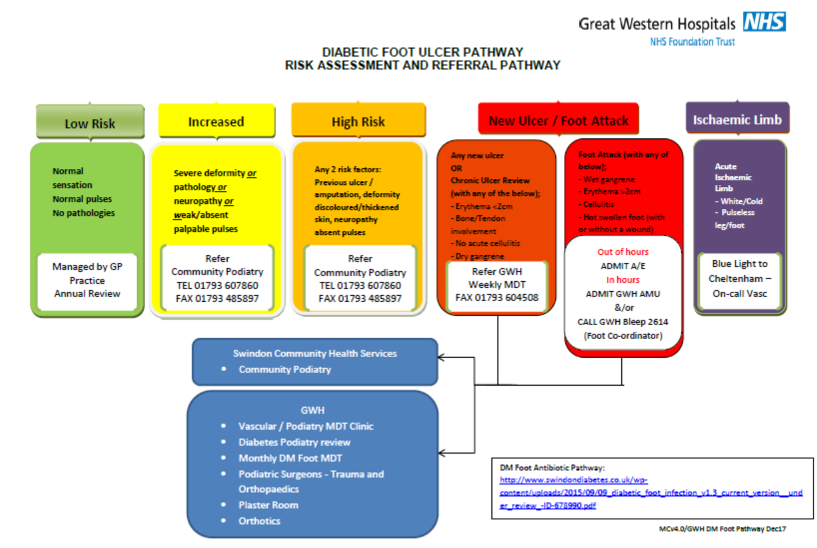
Diabetic foot Ulceration can deteriorate very quickly, TIME IS TISSUE
New Ulcer/Chronic Ulcer Review: Any patient with a newly presenting ulcer must be referred to the DM Foot attack immediately
- If an infection is suspected, the GP should commence antibiotic treatment in line with GWH antibiotic pathway See Antibiotic Pathway) prior to referring.
- Antibiotics should not be delayed if infection is clinically suspected
- Referrals will be seen at the next weekly DM Foot MDT or may be triaged to be seen prior to the next MDT clinic
Review Cardiovascular risks
- Aim for Blood Pressure less than <140/80
- Review Lipids- TG,LDH,HDL
- Smoking history- if patient is smoking provide smoking cessation advice
Understand the diabetes management, aim for Good Glycaemic control – review HbA1c
Note: option of referring our patients with poor diabetes control to the community diabetes team
Swindon:
SWICCG.CommunityDiabetesService@nhs.net or
Fax: 01793 487435 or Office Telephone: 01793 696621

Wiltshire
Diabetes Referrals: whc.diabetesreferrals@nhs.net
Advice and guidance: whc.diabetesnurses@nhs.net
Tel North, East and West – 01249 456483

